**National University – Manila**

**College of Computing and Information Technologies**

**Advanced Database system**



**Samsung Customer Relationship Management**

**Van Gonzales Mora**

**Raphael Inigo Madrigal**

**Professor**

**Armida Salazar**

**I.   Introduction**

**Project Description:**

The Samsung CRM System aims to optimize customer relationship management by facilitating efficient handling of customer feedback and data. It serves as a centralized platform to streamline customer interactions, gather valuable feedback, and derive insights to enhance customer satisfaction and loyalty. The system features a user-friendly interface for both customers and staff to interact seamlessly.

**Scope**

The goal of this project is to provide a way to acquire and keep Samsung consumers by using data analysis and surveys.

**Technologies Used**

Here are the lists of technologies used for the making of our project:

* Java Programming Language
* Swing
* MySQL Workbench
* JavaScript

**II.   System Design**

**Database Design**

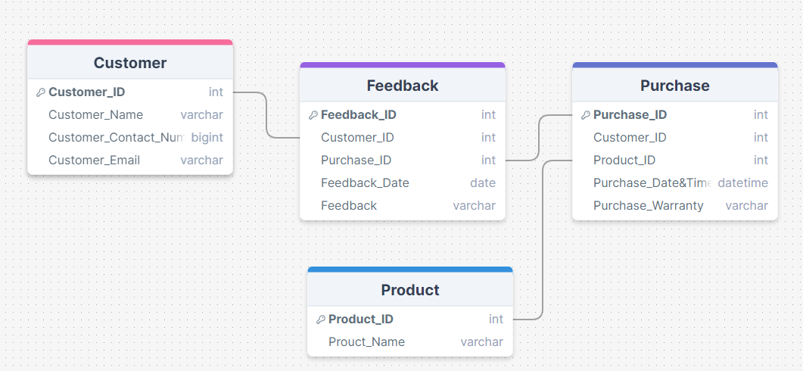

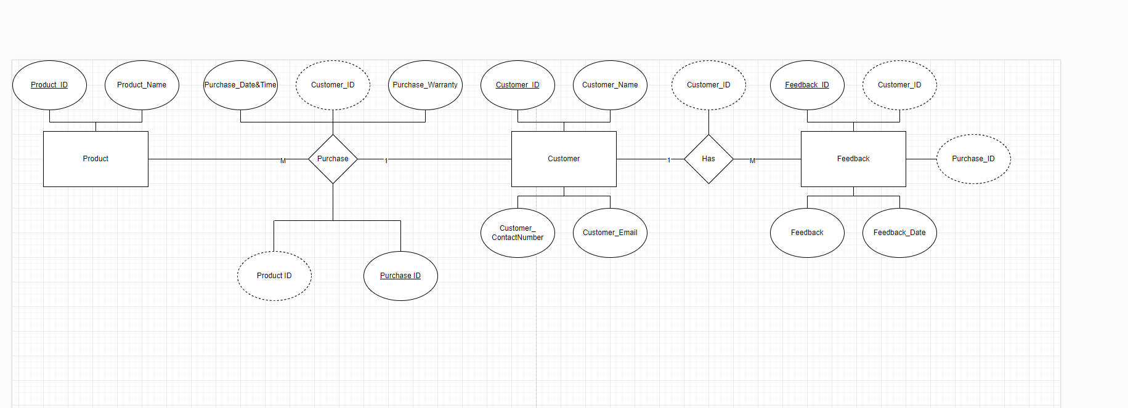 **ER Diagram (Entity-Relationship Diagram)**

**Schema Design**

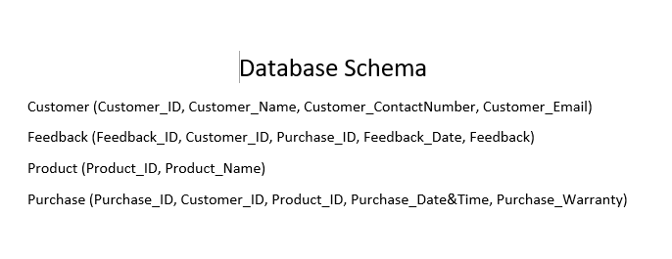

**III. User Interface Design**

• **Login Page Wireframe:**

* **Elements:** Username field, Password field, Login button.
* **Layout:** Centered login form with Samsung logo and minimalistic design.
* **Interaction:** Basic validation for credentials.

• **Customer Feedback List Wireframe:**

* **Elements:** Table with columns for Customer ID, Customer Name, Feedback ID, Feedback Date, Feedback.
* **Layout:** Clean and organized layout with scrollable table.
* **Interaction:** Read-only table, sorting and filtering options.

• **Login Page Mockup:**

* **Design:** Samsung logo in the header, modern typography, blue and white color scheme.
* **Elements:** Styled input fields, polished buttons.
* **Interaction:** Hover effects on buttons, error message display.

• **Customer Feedback List Mockup:**

* **Design:** Samsung branding, bold headers, alternating row colors for readability.
* **Elements:** Customized table headers, clean typography.
* **Interaction:** Responsive layout, pagination controls.

**IV.  Implementation**

**SQL Scripts**

“ CREATE TABLE `database_proj`.`customer` (

  `Customer_ID` INT NOT NULL,

  `Customer_Name` VARCHAR(80) NOT NULL,

  `Customer_ContactNumber` INT NOT NULL,

  `Customer_Email` VARCHAR(60) NOT NULL,

  PRIMARY KEY (`Customer_ID`));

CREATE TABLE `database_proj`.`feedback` (

  `Feedback_ID` INT NOT NULL,

  `Customer_ID` INT NOT NULL,

  `Purchase_ID` VARCHAR(45) NOT NULL,

  `Feedback_Date` DATETIME NOT NULL,

  `Feedback` VARCHAR(200) NOT NULL,

  PRIMARY KEY (`Feedback_ID`));

CREATE TABLE `database_proj`.`product` (

  `Product_ID` INT NOT NULL,

  `Product_Name` VARCHAR(45) NOT NULL,

  PRIMARY KEY (`Product_ID`));

CREATE TABLE `database_proj`.`purchase` (

  `Purchase_ID` INT NOT NULL,

  `Customer_ID` INT NOT NULL,

  `Product_ID` INT NOT NULL,

  `Purchase_Date&Time` DATETIME NOT NULL,

  `Purchase_Warranty` VARCHAR(100) NOT NULL,

  PRIMARY KEY (`Purchase_ID`));

Inserts   
   
Customer   
INSERT INTO `database_proj`.`customer` (`Customer_ID`, `Customer_Name`, `Customer_ContactNumber`, `Customer_Email`) VALUES ('111', 'Tom Hord', '214818', 'tomford@gmail.com');

INSERT INTO `database_proj`.`customer` (`Customer_ID`, `Customer_Name`, `Customer_ContactNumber`, `Customer_Email`) VALUES ('112', 'Peter Han', '124512', 'Peterhan@gmail.com');

INSERT INTO `database_proj`.`customer` (`Customer_ID`, `Customer_Name`, `Customer_ContactNumber`, `Customer_Email`) VALUES ('113', 'Sabrina lou', '229312', 'Sabrinalou22@gmail.com');

INSERT INTO `database_proj`.`customer` (`Customer_ID`, `Customer_Name`, `Customer_ContactNumber`, `Customer_Email`) VALUES ('114', 'Han Sy', '219391', 'Hansy@gmail.com');

INSERT INTO `database_proj`.`customer` (`Customer_ID`, `Customer_Name`, `Customer_ContactNumber`, `Customer_Email`) VALUES ('115', 'Kyle von', '291329', 'kylevon123@gmail.com');

INSERT INTO `database_proj`.`customer` (`Customer_ID`, `Customer_Name`, `Customer_ContactNumber`, `Customer_Email`) VALUES ('116', 'Yesha Anna', '123721', 'Yeshaannaa@gmail.com');

INSERT INTO `database_proj`.`customer` (`Customer_ID`, `Customer_Name`, `Customer_ContactNumber`, `Customer_Email`) VALUES ('117', 'Niki Zefanya', '428532', 'Nikilucy@gmail.com');

INSERT INTO `database_proj`.`customer` (`Customer_ID`, `Customer_Name`, `Customer_ContactNumber`, `Customer_Email`) VALUES ('118', 'Austin Reeves', '248332', 'austinhim@gmail.com');

INSERT INTO `database_proj`.`customer` (`Customer_ID`, `Customer_Name`, `Customer_ContactNumber`, `Customer_Email`) VALUES ('119', 'Mike Ross', '596462', 'Mikeross@gmail.com');

INSERT INTO `database_proj`.`customer` (`Customer_ID`, `Customer_Name`, `Customer_ContactNumber`, `Customer_Email`) VALUES ('120', 'Harvey Specter', '214581', 'harveyspecter@gmail.com');

INSERT INTO `database_proj`.`customer` (`Customer_ID`, `Customer_Name`, `Customer_ContactNumber`, `Customer_Email`) VALUES ('121', 'Emma Watson', '387419', 'emmawatson@gmail.com');

INSERT INTO `database_proj`.`customer` (`Customer_ID`, `Customer_Name`, `Customer_ContactNumber`, `Customer_Email`) VALUES ('122', 'John Doe', '124812', 'johndoe@gmail.com');

INSERT INTO `database_proj`.`customer` (`Customer_ID`, `Customer_Name`, `Customer_ContactNumber`, `Customer_Email`) VALUES ('123', ' Lisa Johnson', '298731', 'lisajohnson@gmail.com');

INSERT INTO `database_proj`.`customer` (`Customer_ID`, `Customer_Name`, `Customer_ContactNumber`, `Customer_Email`) VALUES ('124', 'Michael Smith', '438291', 'mikesmith@gmail.com');

INSERT INTO `database_proj`.`customer` (`Customer_ID`, `Customer_Name`, `Customer_ContactNumber`, `Customer_Email`) VALUES ('125', 'Sarah Parker ', '115623', 'sarahparker@gmail.com');

INSERT INTO `database_proj`.`customer` (`Customer_ID`, `Customer_Name`, `Customer_ContactNumber`, `Customer_Email`) VALUES ('126', 'David Lee', '519823', 'davidlee@gmail.com');

INSERT INTO `database_proj`.`customer` (`Customer_ID`, `Customer_Name`, `Customer_ContactNumber`, `Customer_Email`) VALUES ('127', 'Emily Davis', '672831', 'emilydavis@gmail.com');

INSERT INTO `database_proj`.`customer` (`Customer_ID`, `Customer_Name`, `Customer_ContactNumber`, `Customer_Email`) VALUES ('128', 'Chris Evans', '224912', 'chrisevans@gmail.com');

INSERT INTO `database_proj`.`customer` (`Customer_ID`, `Customer_Name`, `Customer_ContactNumber`, `Customer_Email`) VALUES ('129', 'Jennifer Lopez', '337812', 'jenniferlopez@gmail.com');

INSERT INTO `database_proj`.`customer` (`Customer_ID`, `Customer_Name`, `Customer_ContactNumber`, `Customer_Email`) VALUES ('130', ' Ryan Reynolds', '129381', 'ryanreynolds@gmail.com');

Feedback

INSERT INTO `database_proj`.`feedback` (`Feedback_ID`, `Customer_ID`, `Purchase_ID`, `Feedback_Date`, `Feedback`) VALUES ('3321', '121', '1221', '2023-11-29', 'Disappointed with Samsung\'s customer support and slow software updates');

INSERT INTO `database_proj`.`feedback` (`Feedback_ID`, `Customer_ID`, `Purchase_ID`, `Feedback_Date`, `Feedback`) VALUES ('3322', '122', '1222', '2022-10-13', 'Samsung\'s software updates cause frequent slowdowns and battery drain');

INSERT INTO `database_proj`.`feedback` (`Feedback_ID`, `Customer_ID`, `Purchase_ID`, `Feedback_Date`, `Feedback`) VALUES ('3323', '123', '1223', '2021-04-20', 'Experiencing lag and slow performance after recent Samsung update');

INSERT INTO `database_proj`.`feedback` (`Feedback_ID`, `Customer_ID`, `Purchase_ID`, `Feedback_Date`, `Feedback`) VALUES ('3324', '124', '1224', '2022-08-19', 'Poor gaming performance on Samsung device, disappointed with speed');

INSERT INTO `database_proj`.`feedback` (`Feedback_ID`, `Customer_ID`, `Purchase_ID`, `Feedback_Date`, `Feedback`) VALUES ('3325', '125', '1225', '2022-06-20', 'Considering switching due to better responsiveness with other brands');

INSERT INTO `database_proj`.`feedback` (`Feedback_ID`, `Customer_ID`, `Purchase_ID`, `Feedback_Date`, `Feedback`) VALUES ('3326', '126', '1226', '2021-02-16 ', 'Frequent freezing and sluggish performance on Samsung phone');

INSERT INTO `database_proj`.`feedback` (`Feedback_ID`, `Customer_ID`, `Purchase_ID`, `Feedback_Date`, `Feedback`) VALUES ('3327', '127', '1227', '2022-02-04', 'Apps crashing frequently on Samsung device');

INSERT INTO `database_proj`.`feedback` (`Feedback_ID`, `Customer_ID`, `Purchase_ID`, `Feedback_Date`, `Feedback`) VALUES ('3328', '128', '1228', '2020-12-01', 'Unable to unlock phone due to fingerprint sensor malfunction');

UPDATE `database_proj`.`feedback` SET `Feedback_Date` = '2021-04-22 00:00:00' WHERE (`Feedback_ID` = '3313');

UPDATE `database_proj`.`feedback` SET `Feedback_Date` = '2023-11-21 00:00:00' WHERE (`Feedback_ID` = '3312');

UPDATE `database_proj`.`feedback` SET `Feedback_Date` = '2022-08-13 00:00:00' WHERE (`Feedback_ID` = '3314');

UPDATE `database_proj`.`feedback` SET `Feedback_Date` = '2022-06-02 00:00:00' WHERE (`Feedback_ID` = '3315');

UPDATE `database_proj`.`feedback` SET `Feedback_Date` = '2021-02-11 00:00:00' WHERE (`Feedback_ID` = '3316');

UPDATE `database_proj`.`feedback` SET `Feedback_Date` = '2024-01-04 00:00:00' WHERE (`Feedback_ID` = '3318');

INSERT INTO `database_proj`.`feedback` (`Feedback_ID`, `Customer_ID`, `Purchase_ID`, `Feedback_Date`, `Feedback`) VALUES ('3329', '129', '1229', '2023-05-09', 'Display screen flickers intermittently on Samsung phone');

INSERT INTO `database_proj`.`feedback` (`Feedback_ID`, `Customer_ID`, `Purchase_ID`, `Feedback_Date`, `Feedback`) VALUES ('3330', '130', '1230', '2021-09-17', 'Severe battery drain issue with Samsung phone');

Purchase   
INSERT INTO `database_proj`.`purchase` (`Purchase_ID`, `Customer_ID`, `Product_ID`, `Purchase_Date&Time`, `Purchase_Warranty`) VALUES ('1211', '111', '5111', '2022-07-15', '1yr');

INSERT INTO `database_proj`.`purchase` (`Purchase_ID`, `Customer_ID`, `Product_ID`, `Purchase_Date&Time`, `Purchase_Warranty`) VALUES ('1212', '112', '5112', '2020-11-30', '1yr');

INSERT INTO `database_proj`.`purchase` (`Purchase_ID`, `Customer_ID`, `Product_ID`, `Purchase_Date&Time`, `Purchase_Warranty`) VALUES ('1213', '113', '5113', '2023-03-05', '2yr');

INSERT INTO `database_proj`.`purchase` (`Purchase_ID`, `Customer_ID`, `Product_ID`, `Purchase_Date&Time`, `Purchase_Warranty`) VALUES ('1214', '114', '5114', '2021-09-12', '3yr');

INSERT INTO `database_proj`.`purchase` (`Purchase_ID`, `Customer_ID`, `Product_ID`, `Purchase_Date&Time`, `Purchase_Warranty`) VALUES ('1215', '115', '5115', '2024-01-20', '1yr');

INSERT INTO `database_proj`.`purchase` (`Purchase_ID`, `Customer_ID`, `Product_ID`, `Purchase_Date&Time`, `Purchase_Warranty`) VALUES ('1216', '116', '5116', '2019-08-25', '3yr');

INSERT INTO `database_proj`.`purchase` (`Purchase_ID`, `Customer_ID`, `Product_ID`, `Purchase_Date&Time`, `Purchase_Warranty`) VALUES ('1217', '117', '5117', '2023-06-10', '1yr');

INSERT INTO `database_proj`.`purchase` (`Purchase_ID`, `Customer_ID`, `Product_ID`, `Purchase_Date&Time`, `Purchase_Warranty`) VALUES ('1218', '118', '5118', '2020-04-03', '1yr');

INSERT INTO `database_proj`.`purchase` (`Purchase_ID`, `Customer_ID`, `Product_ID`, `Purchase_Date&Time`, `Purchase_Warranty`) VALUES ('1219', '119', '5119', '2022-10-18', '1yr');

INSERT INTO `database_proj`.`purchase` (`Purchase_ID`, `Customer_ID`, `Product_ID`, `Purchase_Date&Time`, `Purchase_Warranty`) VALUES ('1220', '120', '5120', '2021-12-08', '2yr');

INSERT INTO `database_proj`.`purchase` (`Purchase_ID`, `Customer_ID`, `Product_ID`, `Purchase_Date&Time`, `Purchase_Warranty`) VALUES ('1221', '121', '5121', ' 2023-08-15', ' 2yr');

INSERT INTO `database_proj`.`purchase` (`Purchase_ID`, `Customer_ID`, `Product_ID`, `Purchase_Date&Time`, `Purchase_Warranty`) VALUES ('1222', '122', '5122', '2023-02-28', '1yr');

INSERT INTO `database_proj`.`purchase` (`Purchase_ID`, `Customer_ID`, `Product_ID`, `Purchase_Date&Time`, `Purchase_Warranty`) VALUES ('1223', '123', '5123', '2022-09-25', '3yr');

INSERT INTO `database_proj`.`purchase` (`Purchase_ID`, `Customer_ID`, `Product_ID`, `Purchase_Date&Time`, `Purchase_Warranty`) VALUES ('1224', '124', '5124', '2024-05-18', '1yr');

INSERT INTO `database_proj`.`purchase` (`Purchase_ID`, `Customer_ID`, `Product_ID`, `Purchase_Date&Time`, `Purchase_Warranty`) VALUES ('1225', '125', '5125', ' 2021-11-20', '2yr');

INSERT INTO `database_proj`.`purchase` (`Purchase_ID`, `Customer_ID`, `Product_ID`, `Purchase_Date&Time`, `Purchase_Warranty`) VALUES ('1226', '126', '5126', '2020-06-15', '1yr');

INSERT INTO `database_proj`.`purchase` (`Purchase_ID`, `Customer_ID`, `Product_ID`, `Purchase_Date&Time`, `Purchase_Warranty`) VALUES ('1227', '127', '5127', ' 2023-04-30', '2yr');

INSERT INTO `database_proj`.`purchase` (`Purchase_ID`, `Customer_ID`, `Product_ID`, `Purchase_Date&Time`, `Purchase_Warranty`) VALUES ('1228', '128', '5128', '2020-10-23', '1yr');

INSERT INTO `database_proj`.`purchase` (`Purchase_ID`, `Customer_ID`, `Product_ID`, `Purchase_Date&Time`, `Purchase_Warranty`) VALUES ('1229', '129', '5129', '2022-12-10', '1yr');

INSERT INTO `database_proj`.`purchase` (`Purchase_ID`, `Customer_ID`, `Product_ID`, `Purchase_Date&Time`, `Purchase_Warranty`) VALUES ('1230', '130', '5130', '2022-01-15', '2yr');

Product   
INSERT INTO `database_proj`.`product` (`Product_ID`, `Product_Name`) VALUES ('5111', 'Samsung a50s');

INSERT INTO `database_proj`.`product` (`Product_ID`, `Product_Name`) VALUES ('5112', 'Samsung a71');

INSERT INTO `database_proj`.`product` (`Product_ID`, `Product_Name`) VALUES ('5113', 'Samsung Earbuds');

INSERT INTO `database_proj`.`product` (`Product_ID`, `Product_Name`) VALUES ('5114', 'Samsung note 9');

INSERT INTO `database_proj`.`product` (`Product_ID`, `Product_Name`) VALUES ('5115', 'Samsung flip 1');

INSERT INTO `database_proj`.`product` (`Product_ID`, `Product_Name`) VALUES ('5116', 'Samsung s21');

INSERT INTO `database_proj`.`product` (`Product_ID`, `Product_Name`) VALUES ('5117', 'Samsung TV');

INSERT INTO `database_proj`.`product` (`Product_ID`, `Product_Name`) VALUES ('5118', 'Samsung a03');

INSERT INTO `database_proj`.`product` (`Product_ID`, `Product_Name`) VALUES ('5119', 'Samsung a03s');

INSERT INTO `database_proj`.`product` (`Product_ID`, `Product_Name`) VALUES ('5120', 'Samsung s23');

INSERT INTO `database_proj`.`product` (`Product_ID`, `Product_Name`) VALUES ('5121', 'Samsung Galaxy S20');

INSERT INTO `database_proj`.`product` (`Product_ID`, `Product_Name`) VALUES ('5122', 'Samsung Galaxy A52');

INSERT INTO `database_proj`.`product` (`Product_ID`, `Product_Name`) VALUES ('5123', 'Samsung Galaxy Note 10');

INSERT INTO `database_proj`.`product` (`Product_ID`, `Product_Name`) VALUES ('5124', 'Samsung Galaxy Z Fold 3');

INSERT INTO `database_proj`.`product` (`Product_ID`, `Product_Name`) VALUES ('5125', 'Samsung Galaxy A32');

INSERT INTO `database_proj`.`product` (`Product_ID`, `Product_Name`) VALUES ('5126', 'Samsung Galaxy S20 FE');

INSERT INTO `database_proj`.`product` (`Product_ID`, `Product_Name`) VALUES ('5127', 'Samsung Galaxy S10');

INSERT INTO `database_proj`.`product` (`Product_ID`, `Product_Name`) VALUES ('5128', 'Samsung Galaxy A12');

INSERT INTO `database_proj`.`product` (`Product_ID`, `Product_Name`) VALUES ('5129', 'Samsung Galaxy Fold');

INSERT INTO `database_proj`.`product` (`Product_ID`, `Product_Name`) VALUES ('5130', 'Samsung Galaxy S10 Lite'); “

Data Insertion

Sample Data

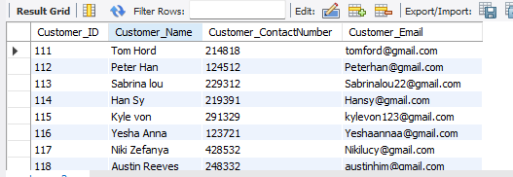

Application Development

Frontend

The User Interface design was developed using Eclipse IDE, by adding java swing for design and images.

Backend

The application back-end was developed using MySQL Workbench.

V.   Conclusion

**Summary of Work Done**

The CRM system effectively manages customer relationships, feedback, and insights into why Samsung users switch to other brands. The system supports strategic decision-making and customer retention efforts by organizing data into interconnected tables and leveraging feedback analysis. This summary encapsulates the foundational aspects and objectives of the CRM system designed to understand customer behavior and improve brand strategy based on feedback analysis.

Samsung users often switch to other smartphone brands due to recurring issues and dissatisfaction with Samsung's products and customer service. Frequent network disruptions from updates, delays in claims processing, and ongoing performance degradation after updates contribute to frustration. Users also experience slow performance, freezing, and overheating, which hinder usability and reliability. The lack of responsiveness from customer service further exacerbates these issues, leading to missed opportunities and a general perception of unmet expectations. As a result, users seek alternatives from brands perceived to offer better reliability, performance, and customer support.

**Challenges Encountered:**

Developing Samsung's CRM system presented several hurdles. Integrating with MySQL required meticulous schema design and data synchronization to ensure data consistency across tables. Designing a cohesive user interface posed challenges in maintaining a consistent look while meeting various user role requirements and functionalities.

**Lesson Gained:**

The journey of building Samsung's CRM system provided valuable insights. Effective initial requirements gathering before development helped prevent scope creep and ensured alignment with business objectives. Adopting an agile development approach enabled iterative improvements and responsiveness to evolving requirements.

**Future Enhancements:**

My team plans to enhance its CRM system with advanced analytics and reporting capabilities to derive actionable insights from customer feedback and behavior trends. Prioritizing mobile compatibility will enable seamless access and functionality across different devices. Integration of AI for personalized customer interactions and predictive analytics aims to enhance engagement and satisfaction.